Spam Filter

🛡️ What Is the Spam Filter Component in a Mail Server System?
# Source: AI Source: Provided by: [Data Path: Persons Table -> ID Column: 1, Name_En Column: Motasem Essam] -> From: [Chatgpt (GPT‑5 Mini)] on [1/21/2026]
A Spam Filter is a security component in a mail server that detects and blocks unwanted or malicious emails — commonly known as spam.
It sits between the internet and the user's inbox to filter out junk mail before it reaches the user.

🧠 Why Is It Important?
# Source: AI Source: Provided by: [Data Path: Persons Table -> ID Column: 1, Name_En Column: Motasem Essam] -> From: [Chatgpt (GPT‑5 Mini)] on [1/21/2026]
Without a spam filter:
- Users are flooded with phishing emails, ads, scams, and malware.
- It puts businesses and users at risk of data breaches or email fraud.
- It wastes server resources and storage.

⚙️ How It Works
# Source: AI Source: Provided by: [Data Path: Persons Table -> ID Column: 1, Name_En Column: Motasem Essam] -> From: [Chatgpt (GPT‑5 Mini)] on [1/21/2026]
Spam filters use a mix of rules and intelligence to identify bad email:
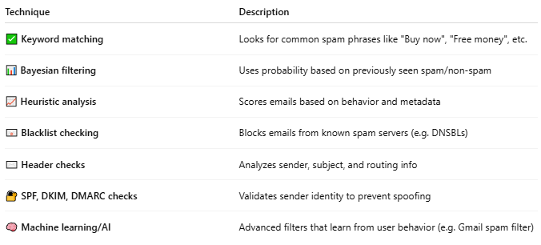

Technique | Description
✅ Keyword matching | Looks for common spam phrases like "Buy now", "Free money", etc.
📊 Bayesian filtering | Uses probability based on previously seen spam/non-spam
📈 Heuristic analysis | Scores emails based on behavior and metadata
📧 Blacklist checking | Blocks emails from known spam servers (e.g. DNSBLs)
✉️ Header checks | Analyzes sender, subject, and routing info
🔐 SPF, DKIM, DMARC checks | Validates sender identity to prevent spoofing
🧠 Machine learning/AI | Advanced filters that learn from user behavior (e.g. Gmail spam filter)

🔁 Where It Fits in the Mail System
# Source: AI Source: Provided by: [Data Path: Persons Table -> ID Column: 1, Name_En Column: Motasem Essam] -> From: [Chatgpt (GPT‑5 Mini)] on [1/21/2026]
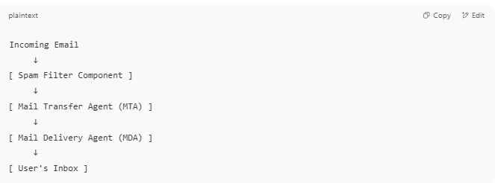

Incoming Email
↓
[ Spam Filter Component ]
↓
[ Mail Transfer Agent (MTA) ]
↓
[ Mail Delivery Agent (MDA) ]
↓
[ User's Inbox ]

🧰 Common Spam Filter Tools
# Source: AI Source: Provided by: [Data Path: Persons Table -> ID Column: 1, Name_En Column: Motasem Essam] -> From: [Chatgpt (GPT‑5 Mini)] on [1/21/2026]
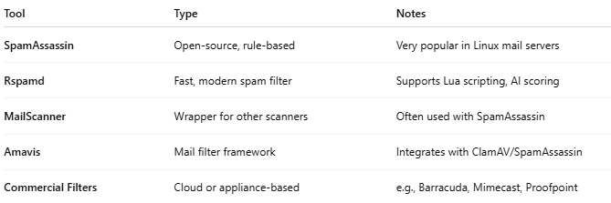

Tool | Type | Notes
SpamAssassin | Open-source, rule-based | Very popular in Linux mail servers
Rspamd | Fast, modern spam filter | Supports Lua scripting, AI scoring
MailScanner | Wrapper for other scanners | Often used with SpamAssassin
Amavis | Mail filter framework | Integrates with ClamAV/SpamAssassin
Commercial Filters | Cloud or appliance-based | e.g., Barracuda, Mimecast, Proofpoint

✅ Summary
# Source: AI Source: Provided by: [Data Path: Persons Table -> ID Column: 1, Name_En Column: Motasem Essam] -> From: [Chatgpt (GPT‑5 Mini)] on [1/21/2026]
The Spam Filter Component protects your mail system by automatically blocking or flagging unwanted emails, ensuring users only get legitimate, safe messages.

